**SETUP GITHUB**

1. Download git on: <https://git-scm.com/downloads>

You can either download git or the the git gui client.

1. Go to github and click on clone or download and copy and paste the URL

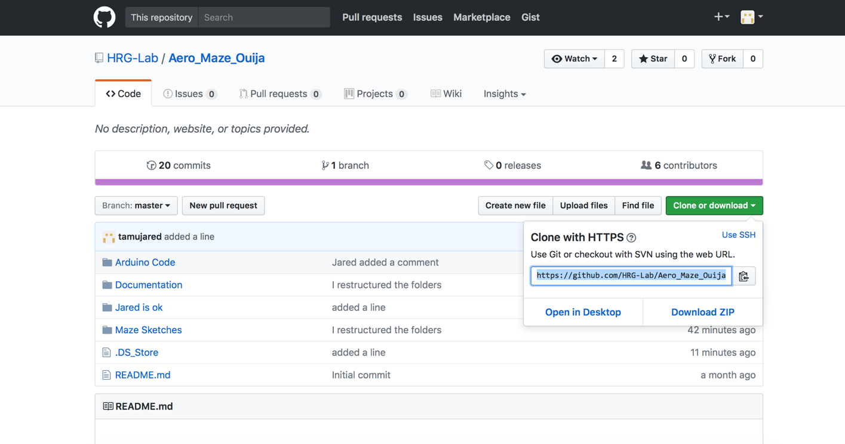

1. Go to either terminal (Mac) or gitbash (PC) and navigate to your folder you want to place the github repository in.

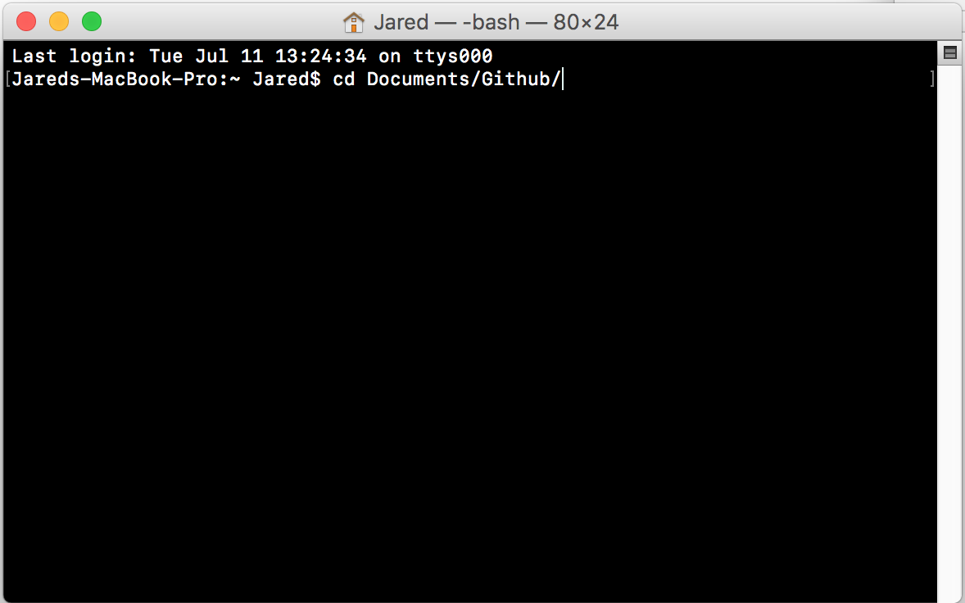

1. Type in **git clone website** where “website” is the link you copied earlier

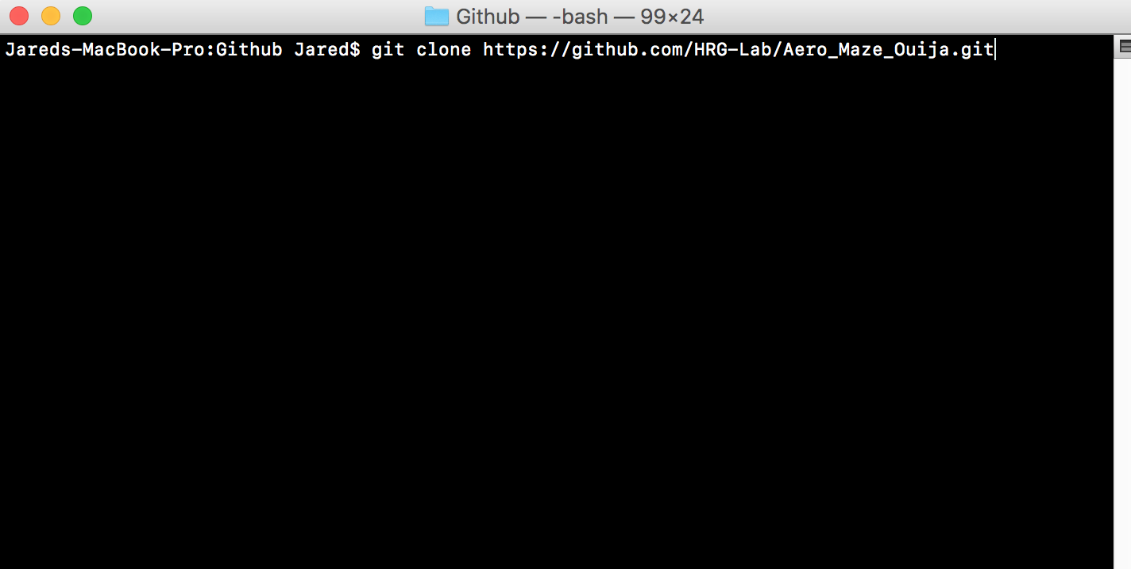

Your files should be set up, so if you go back to your file browser on your computer, everything will be there.

**RETRIEVE FILES UPDATED FILES**

In order to update to the latest version of the files type in ‘git pull’ this will pull the information onto your computer

**SEND YOUR UPDATED FILES**

In github type in **git add -A** this says that we will update all the files

Type in **git commit -m ”Put your comments here”**

Type in **git push** this will push your documents to the repository

**TIPS**

-You use **git status** to view the status

-If you get stuck executing a program try pressing control-z

-use this link to learn how to navigate your files: <http://www.ee.surrey.ac.uk/Teaching/Unix/>

-Use **cd** to change directory

-Use **cd ..** to back out of a directory

-Use **ls** to view the contents of the directory

**FAQ**

-If you need to change your home directory type in:

setx HOME "your\path\to\home"

and change “home” to the file path you want it to be (i.e. /c/users/Username)